

MNS University of Agriculture, Multan.
Programming Fundamentals-303
Lab-1
Submitted to: Ma’am Rashda Nazeer
Submitted by: Mahnoor Faheem

Task-1:
Write a program that prints your name, roll number and program on separate lines. 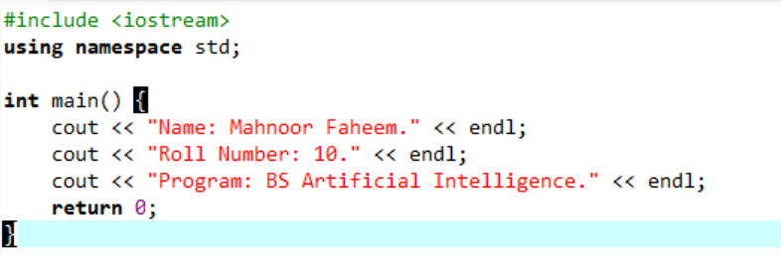

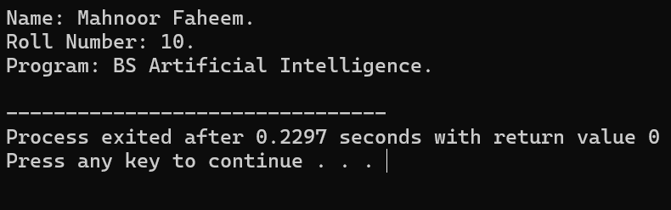
Task-2:
Print a box of asterisks row heigh and 10 columns wide using cout statements.
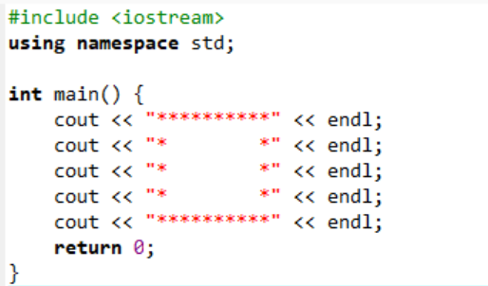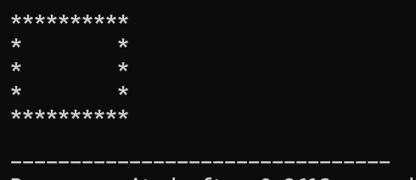
Task-3:
Record three different compiler errors and explain what caused each.
